RootsPlus

Project Overview

RootsPlus is a smart agricultural management platform that helps farms work more efficiently and sustainably. It brings together farm data, crop details, activities, and evaluations in one place, making it easier to plan, monitor, and improve operations.

Our services include Farm Supervision & Monitoring, Farm Design & Construction, and Agricultural Consulting & Evaluations. With expert guidance and data‑driven insights, we help farmers boost yields, reduce costs, and achieve long‑term growth.

RootsPlus connects traditional farming with modern technology giving every farm the tools to grow stronger from the roots up.

Key Features of the Platform

* Centralized Farm Database – All farm, crop, and activity records in one place.
* Activity Tracking – Record and monitor agricultural tasks linked to specific crops and fields.
* Performance Evaluations – Data‑driven insights into yield, cost efficiency, and operational quality.
* Role‑Based Access – Secure login for agronomists and authorized staff only.
* Scalable Architecture – Designed to grow with the business, supporting multiple farms and users.

How RootsPlus Works

RootsPlus is built on a structured, data‑driven architecture that connects every part of farm management into one seamless system.

1. User Roles & Access
   * Only authorized Agronomists can log in and manage farm data.
   * Farm owners can easily register on the platform and add their farm details, making it simple to get started.
   * Secure authentication ensures that all sensitive information is protected.
2. Farm & Crop Management
   * Each farm is linked to its owner and assigned agronomists.
   * Crops are registered under specific farms, with details like planting dates, area, and status.
3. Activity Tracking
   * Agronomists record daily activities (e.g., irrigation, fertilization, pest control) linked to both the farm and the specific crop.
   * This creates a clear history of work done, who did it, and when.
4. Evaluations & Insights
   * Periodic evaluations measure yield, activity performance, and cost efficiency.
   * Data is analyzed to highlight strengths, identify issues, and recommend improvements.
5. 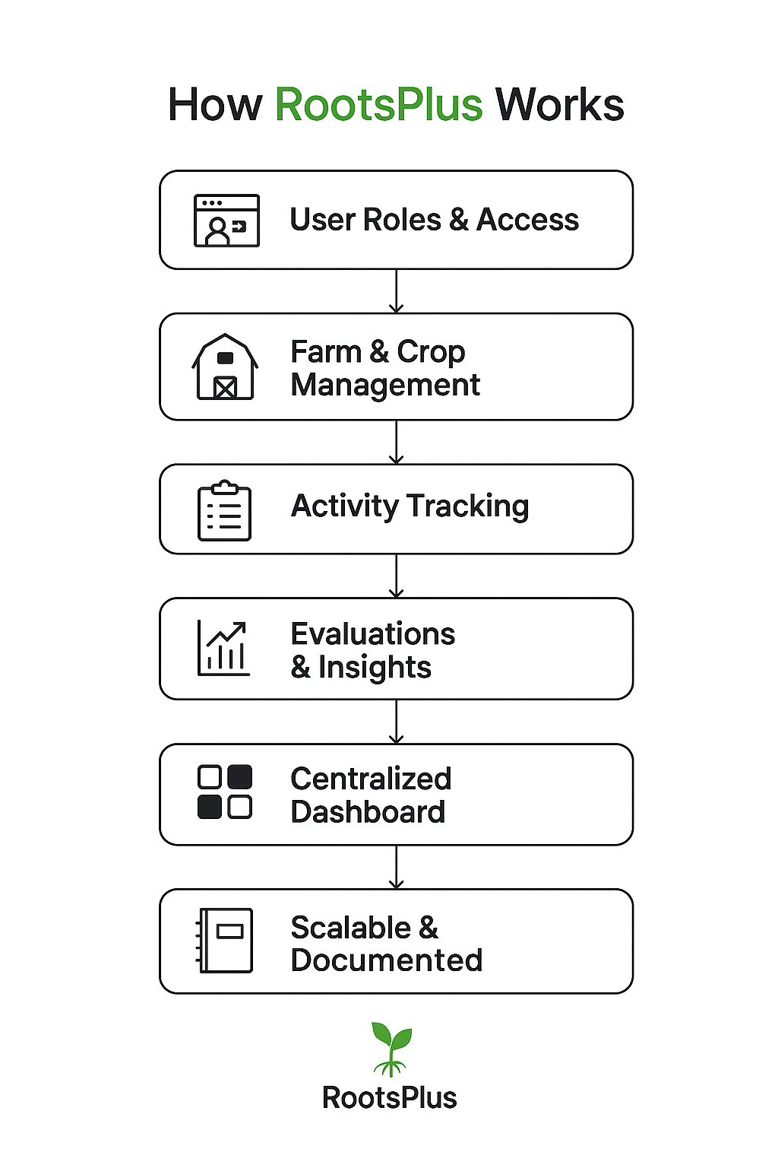Centralized Dashboard
   * The wireframed dashboard gives agronomists a clear view of farms, crops, activities, and evaluations in one place.
   * Filters, search tools, and visual indicators make it easy to monitor progress and take action quickly.
6. Scalable & Documented
   * The platform’s modular design (as shown in the ERD and class structure) allows for easy expansion.
   * Every feature is backed by clear documentation, ensuring smooth onboarding and future development.

Project Requirements

1. Functional Requirements *(What the system must do)*

* User Registration & Login – Secure sign‑up and authentication for farm owners, agronomists, and admins.
* Role Management – Different permissions for each role (e.g., agronomist, farm owner, admin).
* Farm Management – Add, edit, and view farm details linked to owners and agronomists.
* Crop Management – Register crops under specific farms with key details (type, planting date, area, etc.).
* Activity Tracking – Record agricultural activities linked to farms, crops, and agronomists.
* Evaluation Module – Seasonal farm evaluations with performance metrics and recommendations.
* Dashboard & Reports – Centralized view of farms, crops, activities, and evaluations with filters and search.
* Notifications – Alerts for upcoming tasks, evaluations, or important updates.

2. Technical Requirements *(How the system will work)*

* Backend Framework – Django (Python) for robust, scalable server‑side logic.
* Database – MySQL for structured, relational data storage.
* Frontend – HTML, CSS (Bootstrap), and JavaScript for responsive UI.
* AJAX Integration – Smooth, real‑time updates without page reloads.
* RESTful API – Secure endpoints for CRUD operations and future integrations.
* Authentication & Security – Encrypted passwords, role‑based access control.
* Scalable Architecture – Modular design for easy feature expansion.

3. Non‑Functional Requirements *(Quality standards)*

* Usability – Simple, intuitive interface for both technical and non‑technical users.
* Performance – Fast load times and optimized queries for large datasets.
* Reliability – Stable operation with minimal downtime.
* Maintainability – Clean, documented code for easy updates.
* Compatibility – Works across modern browsers and devices.

ERD Diagram and relationships

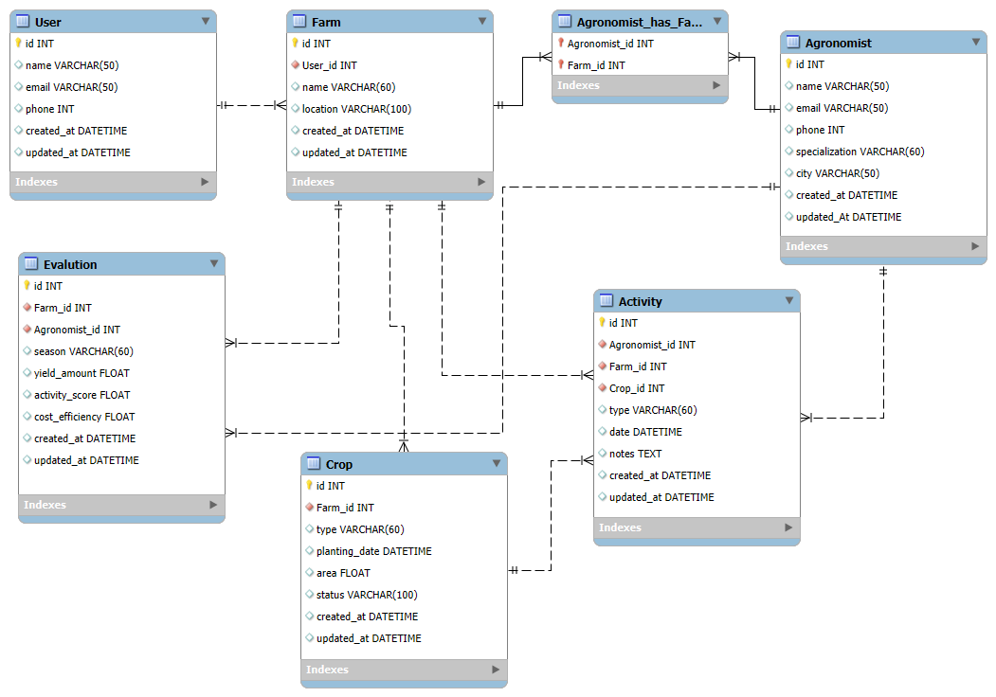

Core Entities

|  |  |
| --- | --- |
| Entity | Description |
| User | A general system user (e.g., admin, supervisor, etc.). |
| Agronomist | A specialized agricultural engineer. |
| Farm | A farm linked to a User and one or more Agronomists. |
| Crop | A crop grown within a specific farm. |
| Activity | An agricultural task linked to a farm, crop, and agronomist. |
| Evaluation | A seasonal farm assessment conducted by an agronomist. |
| Agronomist_has_Farm | A junction table for the many‑to‑many relationships between  agronomists and farms. |

Defined Relationships

|  |  |  |
| --- | --- | --- |
| Relationship | Type | Explanation |
| Farm → User | Many‑to‑One | Each farm has a single owner or manager. |
| Farm ↔ Agronomist | Many‑to‑Many | Multiple agronomists can supervise the same farm, and each agronomist can manage multiple farms. |
| Crop → Farm | Many‑to‑One | Each crop belongs to one farm. |
| Activity → Farm, Crop, Agronomist | Many‑to‑One | Each activity is linked to a specific farm, crop, and agronomist. |
| Evaluation → Farm, Agronomist | Many‑to‑One | Each evaluation is performed on a farm by a specific agronomist. |

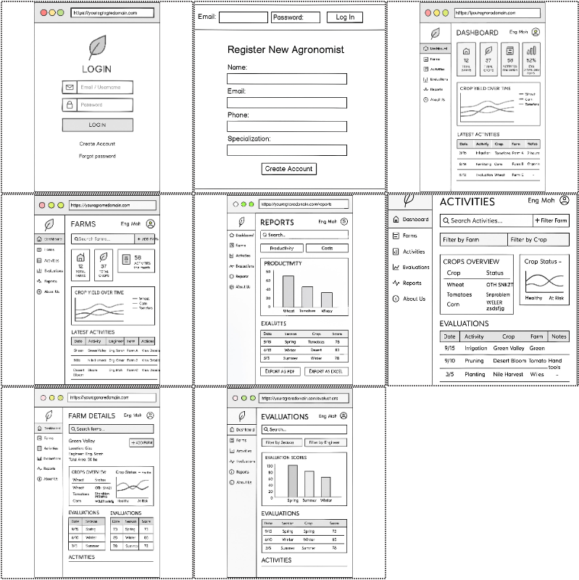Project Wireframe

* Github Repo: [MohDDH/rootsPlus](https://github.com/MohDDH/rootsPlus)
* Trello: [RootsPlus | Trello](https://trello.com/b/vYUzZ4ug/rootsplus)